K.R. Mangalam University



MBA 1st SEMESTER

GROUP ASSIGNMENT

**SUBJECT: MANAGING MARKETING OPERATIONS**

ON THE TOPIC:



UNDERSTANDING THE MARKETING MIX

OF

Submitting to faculty & our Mentor

**Prof. AJIRA ASTHANA**

**Group no - 8**

Praneet - (2302570049)

Sonal choudhary - (2302570019)

Noyal K Jiji - (2302570023)

Anjali Sharma - (2302480001)

Kshitij Gumber - (2302480028)

**1. INTRODUCTION**

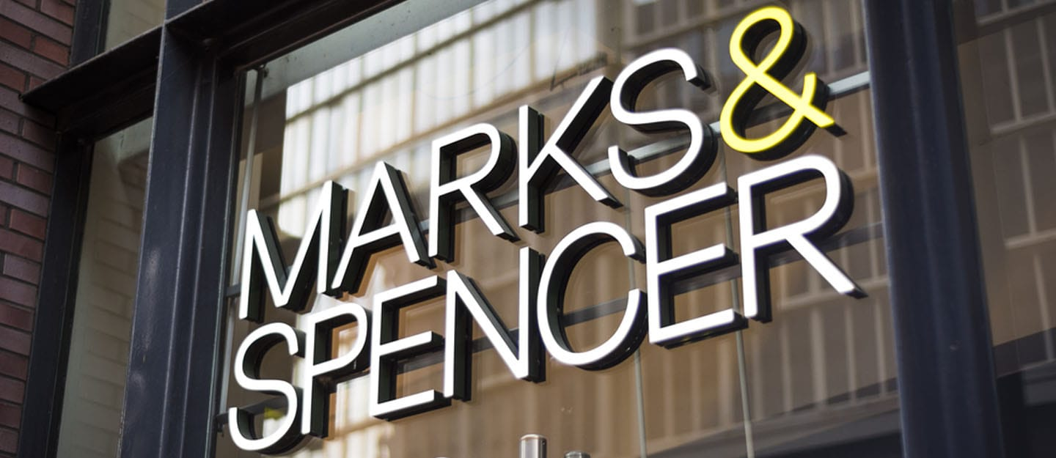Founded in 1884, Marks & Spencer is a major UK retailer with segments in Food, offering groceries and ready meals, and Clothing and home, providing clothing, homeware, furniture, and beauty products.

**2. MARKETING MIX OF “MARKS & SPENCER”**

**2.1 PRODUCT**

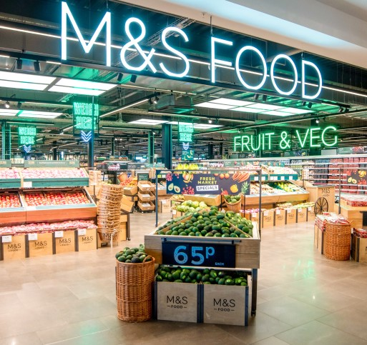

Marks & Spencer offers a comprehensive product range, blending high-end fashion and home goods with a premium food selection. Renowned for sustainable fashion and diverse gourmet options, M&S strategically positions itself as a versatile one-stop-shop, appealing to environmentally conscious consumers and aiming for sustained growth and competitive advantage in the retail market.

**2.2 PRICE**

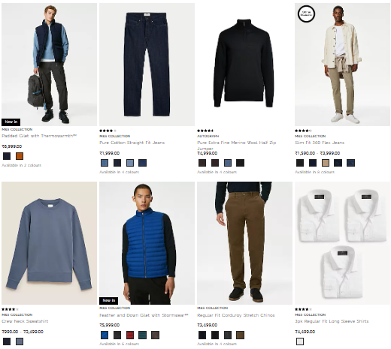

Marks & Spencer employs a competitive pricing strategy across its in-house clothing brands for women, men, and kids, balancing premium quality with affordability. In the face of heightened competition, including online retailers, the company adopts dynamic pricing, offering discounts during seasons and reducing prices on older stock compared to newer arrivals.

**2.3 PLACE**

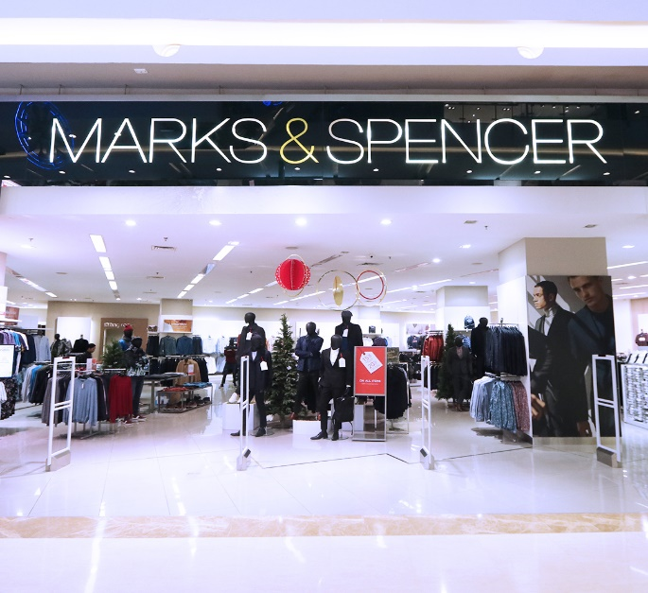

Marks & Spencer strategically positions 1,035 UK and 452 global stores in prime locations, ensuring visibility. Their e-commerce platform broadens reach, while international expansion diversifies revenue. Various store formats cater to diverse preferences, and efficient logistics and partnerships enhance supply chain management for a competitive edge.

**2.4 PROMOTION**

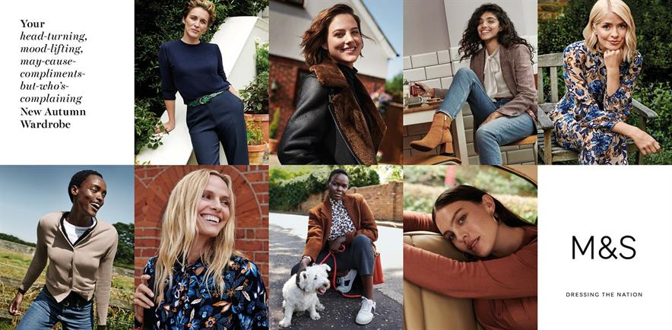

Marks & Spencer adopts an extensive marketing approach, utilizing print, digital, and visual channels. Their strategy emphasizes quality, value, sustainability, and ethical practices. Multi-channel marketing, seasonal campaigns, loyalty programs, and digital innovation enhance customer experience, while social media engagement is pivotal in fostering brand loyalty.